

**Experiment No.:9**

| **TITLE: Study and configure DHCP & DNS protocol using Cisco Packet tracer** |
| --- |

**AIM:** To study and configure **DHCP/DNS** protocol using Cisco Packet tracer

**_____________________________________________________________________________**

**Expected Outcome of Experiment:**

**CO:**

**_____________________________________________________________________________**

**Books/ Journals/ Websites referred:**

1. A. S. Tanenbaum, “Computer Networks”, Pearson Education, Fourth Edition
2. B. A. Forouzan, “Data Communications and Networking”, TMH, Fourth Edition

_____________________________________________________________________________

**Pre Lab/ Prior Concepts:**

IPv4 Addressing, Subnetting, Link State Protocol, Router configuration Commands

**_____________________________________________________________________________**

**New Concepts to be learned: DHCP/DNS** Protocol and its configuration.

**_____________________________________________________________________________**

**THEORY:**

### DHCP (Dynamic Host Configuration Protocol)

* **Purpose: Automatically assigns IP addresses and network settings to devices on a network.**
* **Process: Devices send a request to a DHCP server, which responds with an available IP address and configuration details.**
* **Benefits: Simplifies network management and prevents IP conflicts.**

### DNS (Domain Name System)

* **Purpose: Translates domain names (like www.cn.com) into IP addresses (like 192.0.2.1).**
* **Process: When a user types a domain name, a DNS resolver queries DNS servers to find the corresponding IP address.**
* **Benefits: Makes the internet user-friendly and allows easy updates to IP addresses.**

**IMPLEMENTATION:**

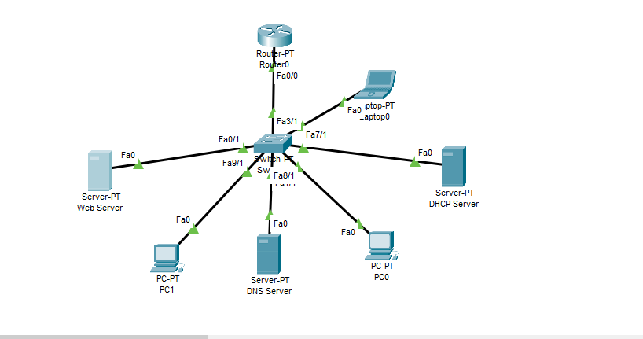

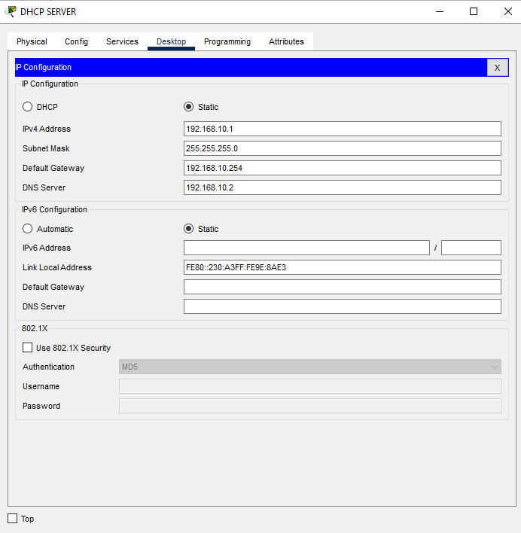

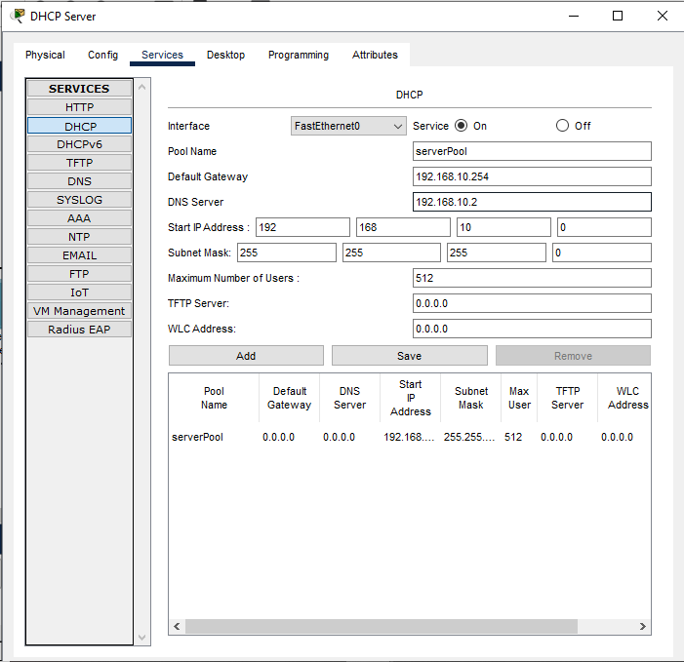

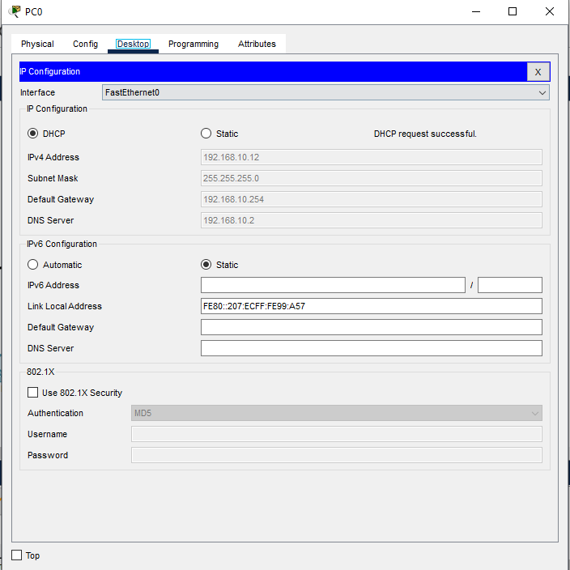

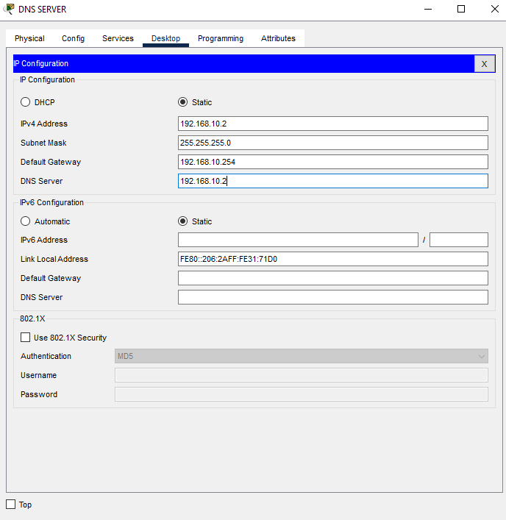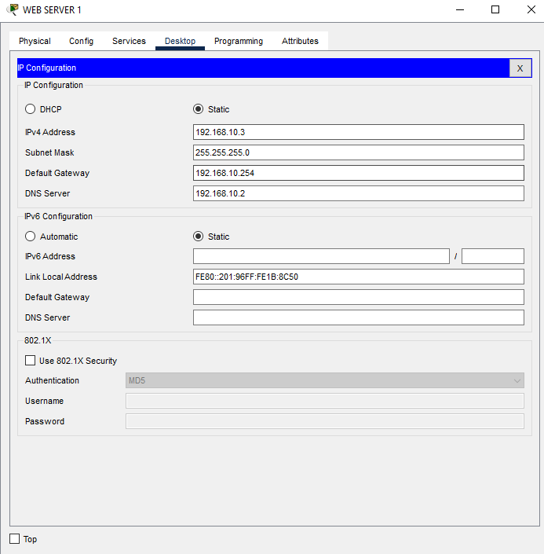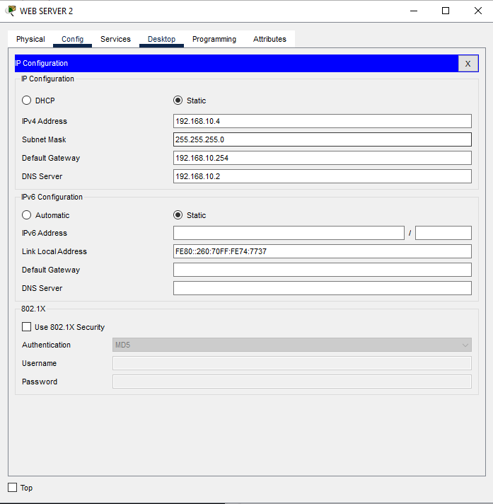

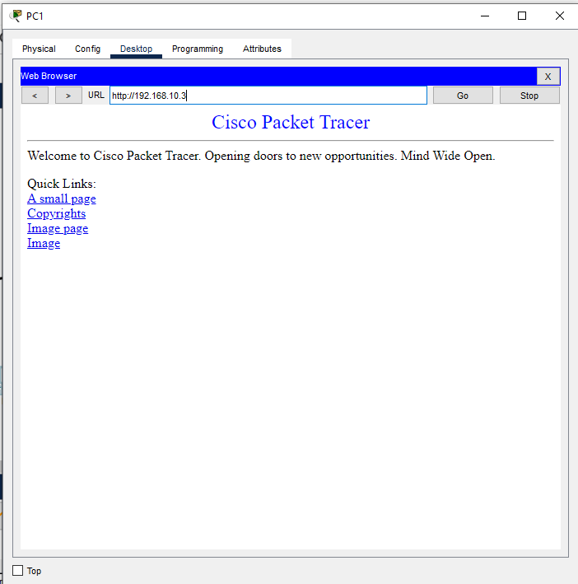

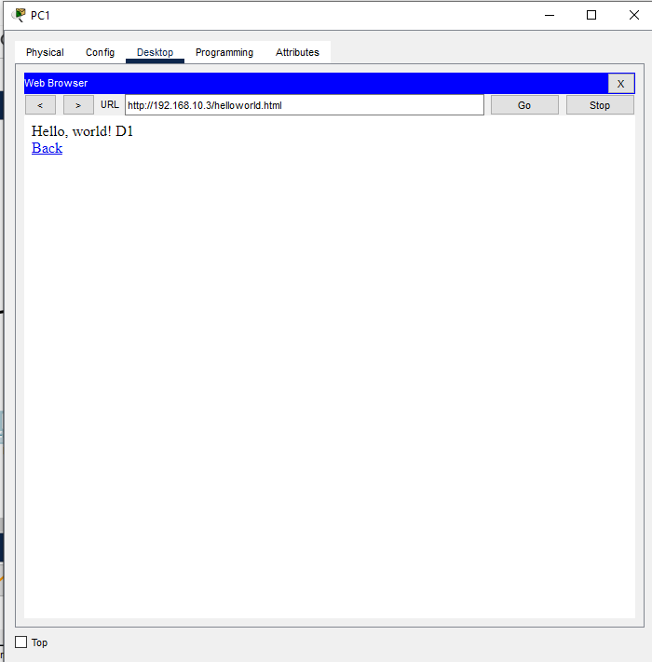

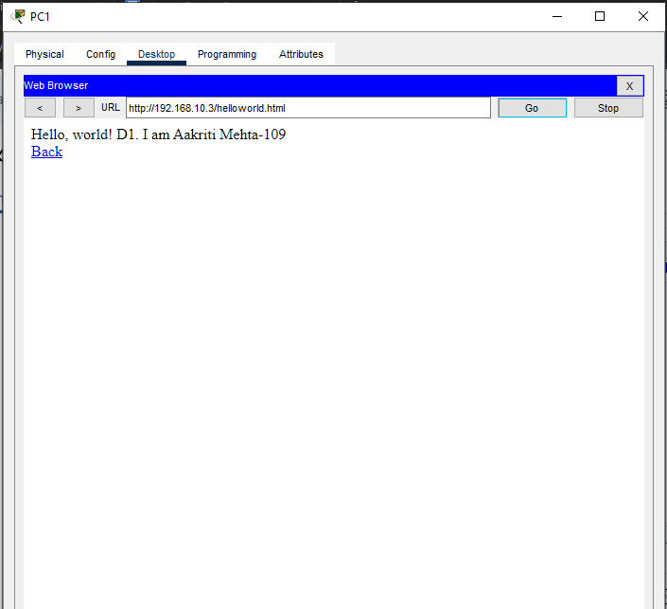

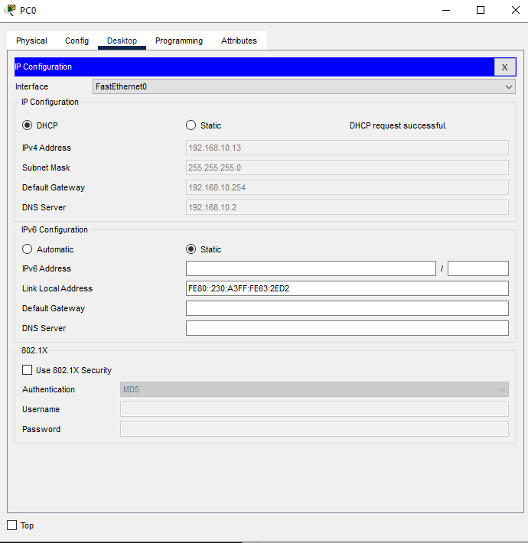

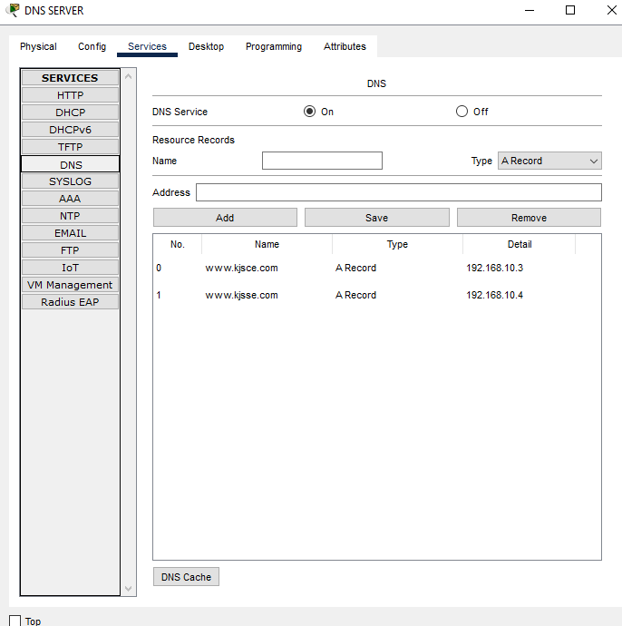

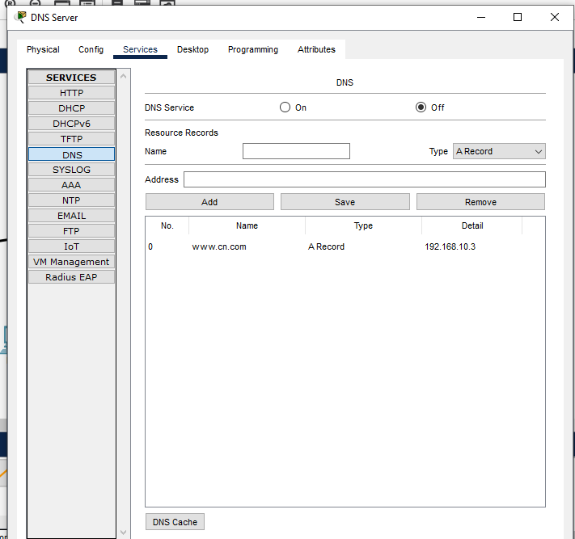

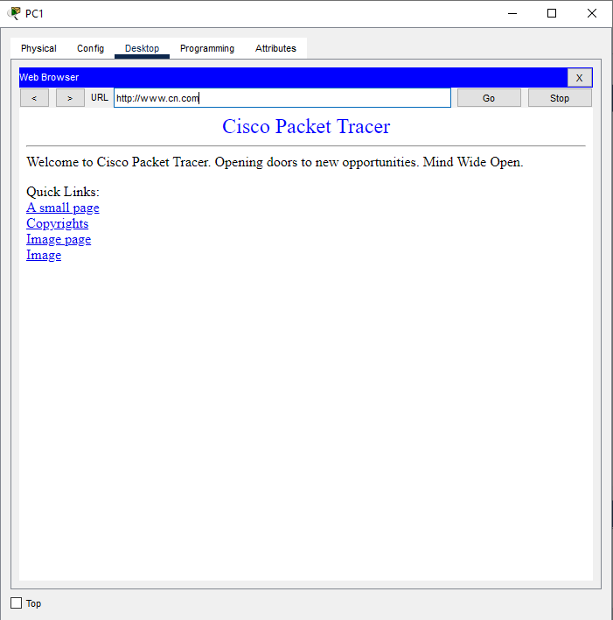

**CONCLUSION:**

**Learnt DHCP , DNS and Web Server using cisco packet tracer.**

**Date: 21 / 10 / 24 Signature of faculty in-charge**